//Program to print a content using printf() and puts()

#include <stdio.h>

int main()

{

//using puts

puts("Name – HARJOT SINGH");

puts("Branch - Electrical Engineering");

puts("Class Roll No. - 2016021");

puts("Home Town - PURAIN");

puts("Passion –DRIVING");

printf("Name - HARJOT SINGH\nBranch - Electrical Engineering\nClass Roll No. - 2016021\nHometown - PURAIN\nPassion -DRIVING \n");

return 0;

}

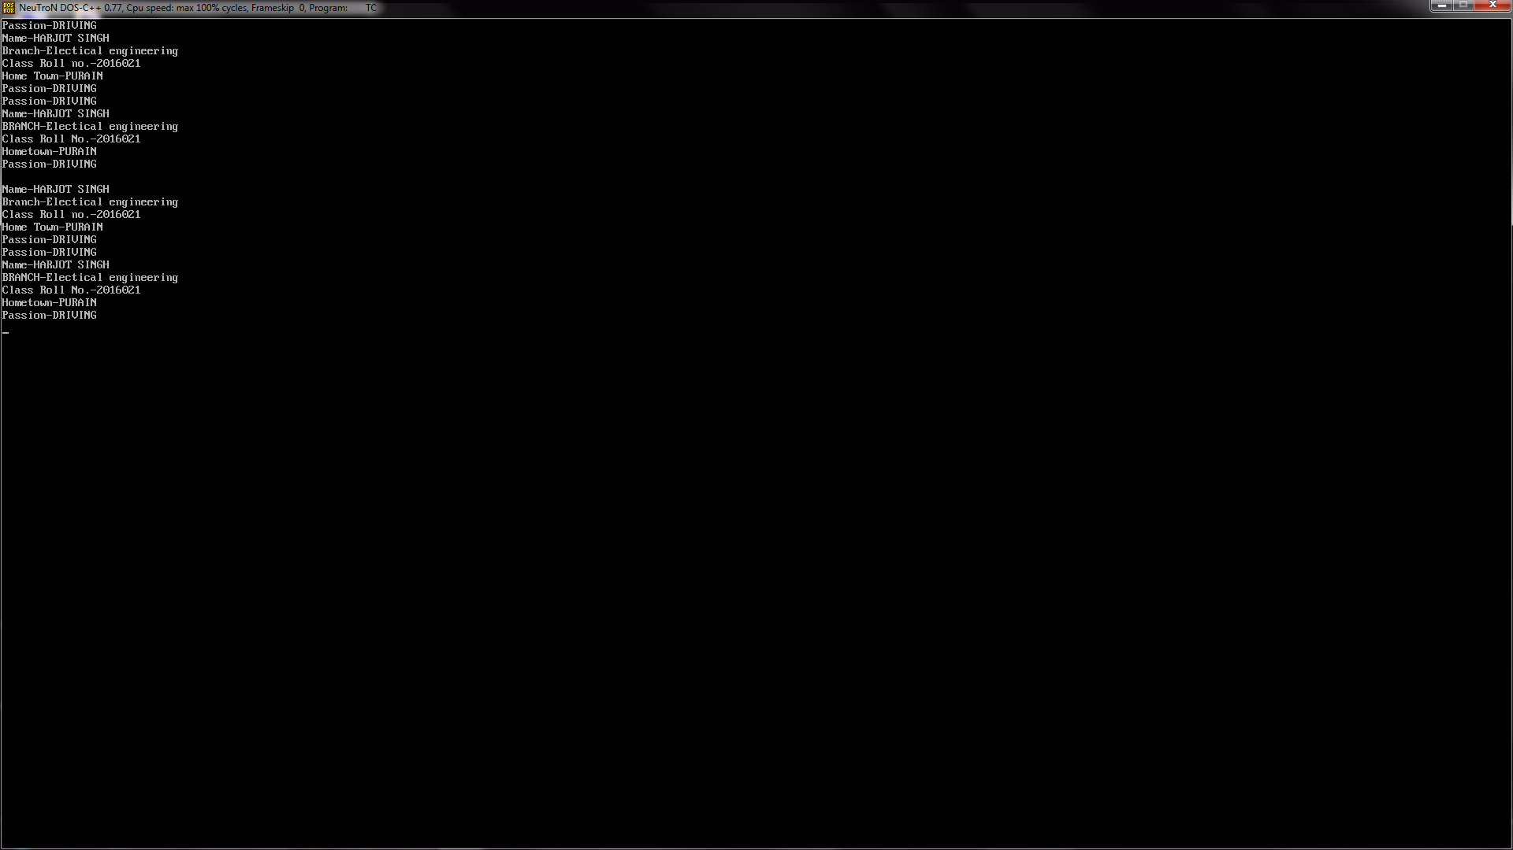

//Program to use different datatypes(int,float,char)

#include <stdio.h>

int main()

{

int a = 10;

float b = 10.10;

char c = c;

printf("%d",a);

printf("%f",b);

printf("%c",c);

return 0;

}

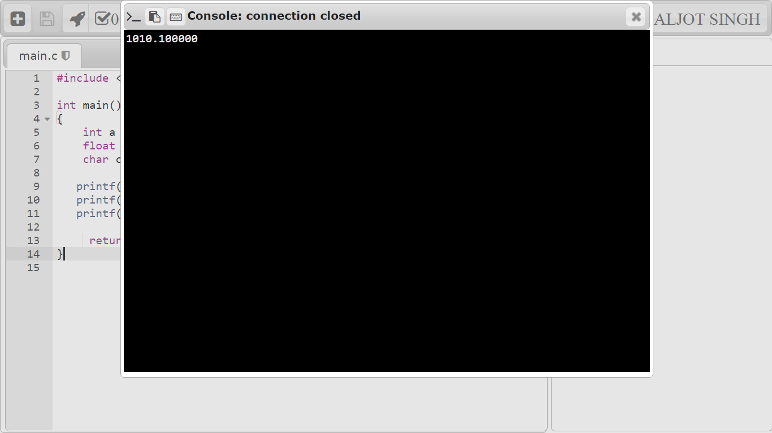

//Program to use arithmetic operators

#include<stdio.h>

int main()

{

int a = 12;

int b = 3;

int addition, subtraction, multiplication, division, modulus;

addition = a + b; //addition of 3 and 12

subtraction = a - b; //subtract 3 from 12

multiplication = a * b; //Multiplying both

division = a / b; //dividing 12 by 3 (number of times)

modulus = a % b; //calculation the remainder

printf("Addition of two numbers a, b is : %d\n", addition);

printf("Subtraction of two numbers a, b is : %d\n", subtraction);

printf("Multiplication of two numbers a, b is : %d\n", multiplication);

printf("Division of two numbers a, b is : %d\n", division);

printf("Modulus of two numbers a, b is : %d\n", modulus);

}

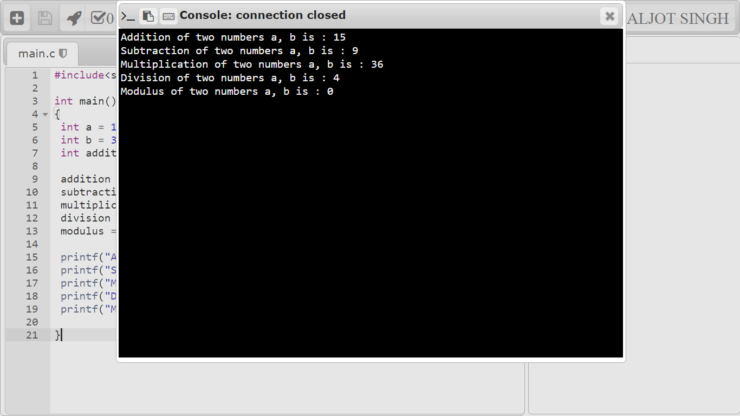

//Program to use logical operators

#include <stdio.h>

void main()

{

int m=40,n=20;

int o=20,p=30;

if (m>n && m !=0)

{

printf("&& Operator : Both conditions are true\n");

}

if (o>p || p!=20)

{

printf("|| Operator : Only one condition is true\n");

}

if (!(m>n && m !=0))

{

printf("! Operator : Both conditions are true\n");

}

else

{

printf("! Operator : Both conditions are true. " \

"But, status is inverted as false\n");

}

}

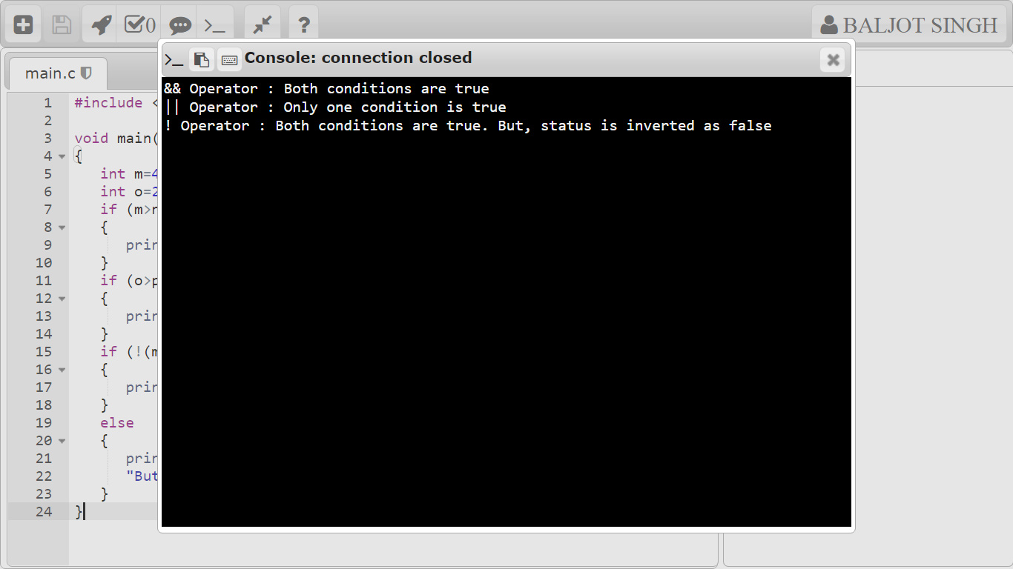

//program to use realional operational operators

#include <stdio.h>

int main()

{

int a = 21;

int b = 10;

int c ;

if( a == b ) {

printf("Line 1 - a is equal to b\n" );

} else {

printf("Line 1 - a is not equal to b\n" );

}

if ( a < b ) {

printf("Line 2 - a is less than b\n" );

} else {

printf("Line 2 - a is not less than b\n" );

}

if ( a > b ) {

printf("Line 3 - a is greater than b\n" );

} else {

printf("Line 3 - a is not greater than b\n" );

}

/* Lets change value of a and b */

a = 5;

b = 20;

if ( a <= b ) {

printf("Line 4 - a is either less than or equal to b\n" );

}

if ( b >= a ) {

printf("Line 5 - b is either greater than or equal to b\n" );

}

return 0;

}

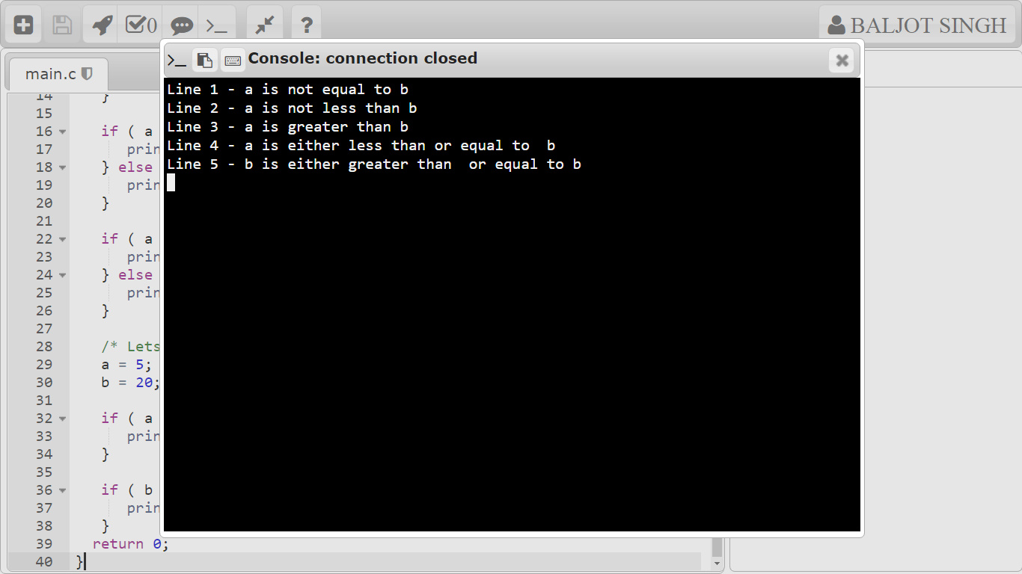

//program to use increment and decrement operators

#include

<stdio.h>

int main()

{

int a = 5, b = 5;

// a is displayed

// Then, a is increased to 6.

printf("%d\n", a++);

// b is increased to 6

// Then, it is displayed.

printf("%d\n", ++b);

return 0;

}

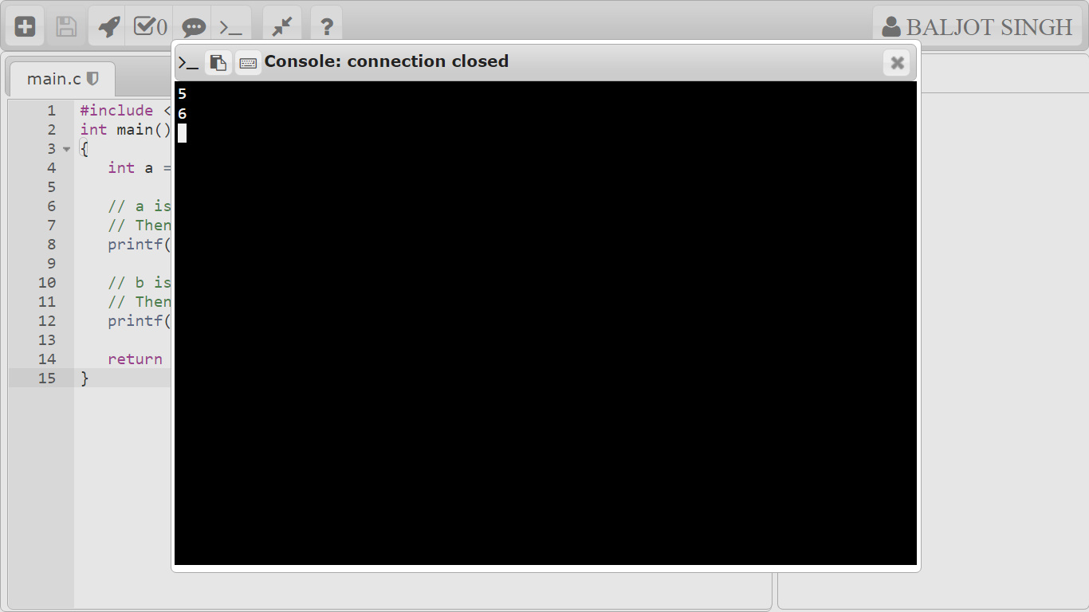

//program to use condiotional statements:if-else,if else ladder

**IF STATEMENT:**

#include <stdio.h>

int main() {

int number;

printf("Enter an integer: ");

scanf("%d", &number);

// true if number is less than 0

if (number < 0) {

printf("You entered %d.\n", number);

}

printf("The if statement is easy.");

return 0;

}

**IF ELSE STATEMENT:**

#include <stdio.h>

int main() {

int number;

printf("Enter an integer: ");

scanf("%d", &number);

// True if the remainder is 0

if (number%2 == 0) {

printf("%d is an even integer.",number);

}

else {

printf("%d is an odd integer.",number);

}

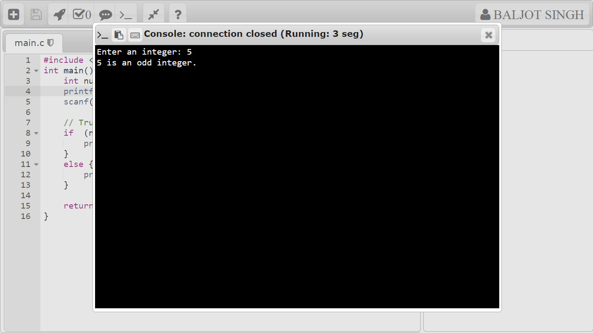 return 0;

**}**

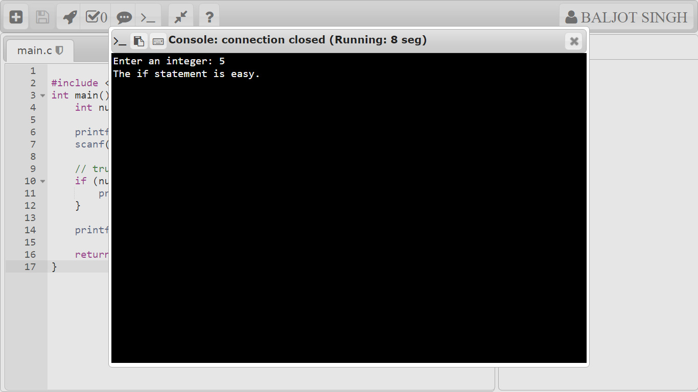

//program to use for loop,nested for loop

**FOR LOOP:**

// Print numbers from 1 to 10

#include <stdio.h>

int main() {

int i;

for (i = 1; i < 11; ++i)

{

printf("%d ", i);

}

return 0;

}

**NESTED FOR LOOP:**

#include <stdio.h>

int main ()

{

/* local variable definition */

int i, j;

for(i = 2; i<100; i++)

{

for(j = 2; j <= (i/j); j++)

if(!(i%j)) break; // if factor found, not prime

if(j > (i/j)) printf("%d is prime\n", i);

return 0;

}

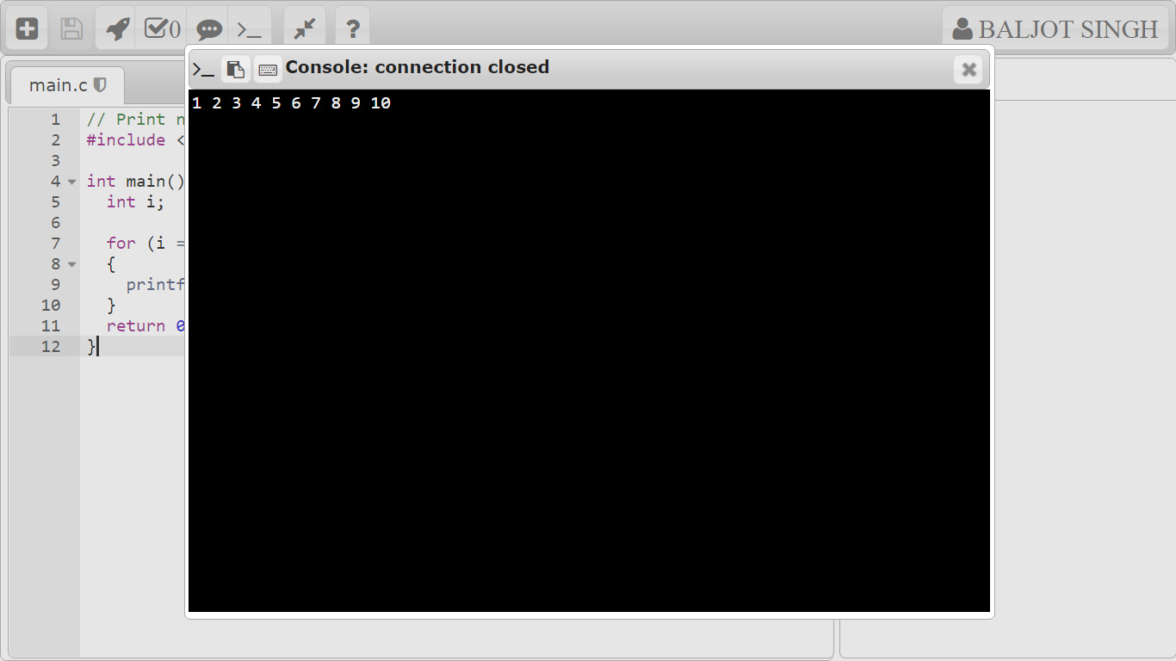

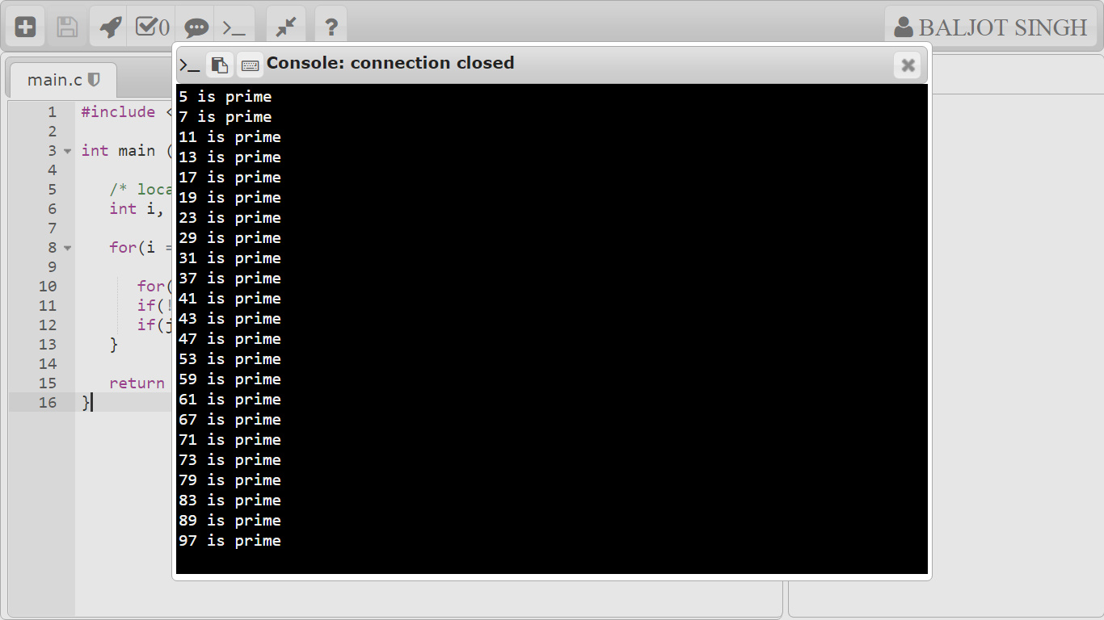

**//program to use while loop,do –while loop**

**WHILE LOOP:**

// Print numbers from 1 to 5

#include <stdio.h>

int main()

{

int i = 1;

while (i <= 5)

{

printf("%d\n", i);

++i;

}

return 0;

}

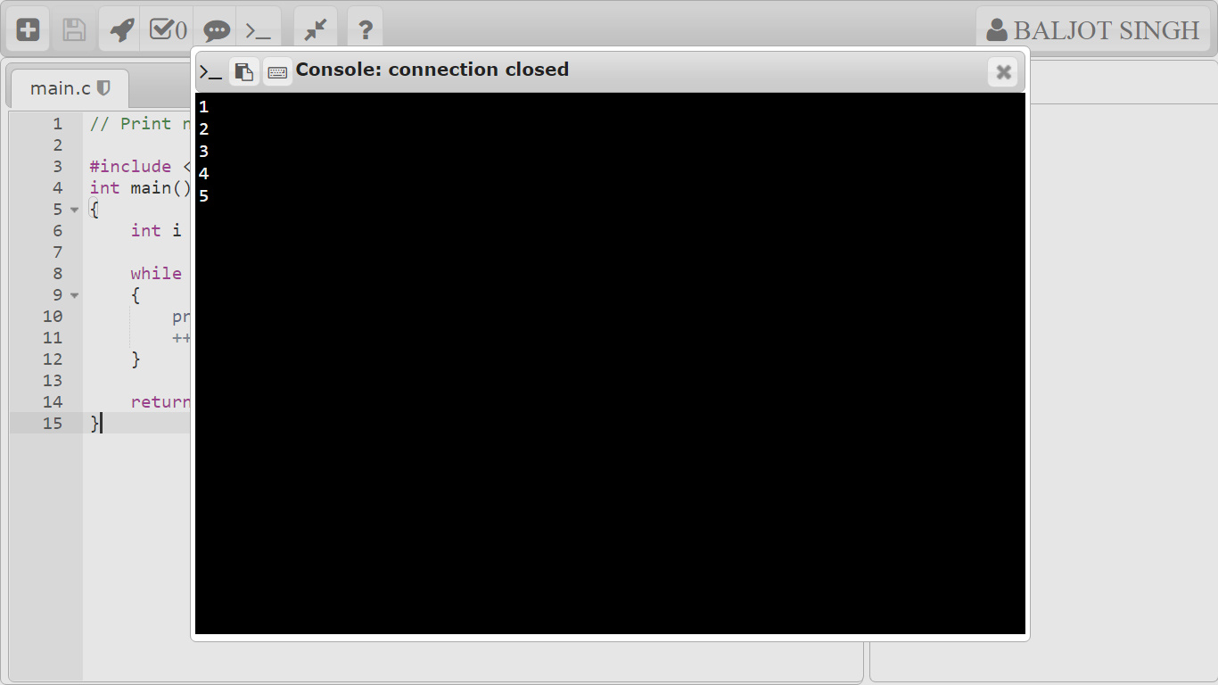

**DO WHILE LOOP:**

**// Program to add numbers until the user enters zero**

#include <stdio.h>

int main()

{

double number, sum = 0;

// the body of the loop is executed at least once

do

{

printf("Enter a number: ");

scanf("%lf", &number);

sum += number;

}

while(number != 0.0);

printf("Sum = %.2lf",sum);

return 0;

}

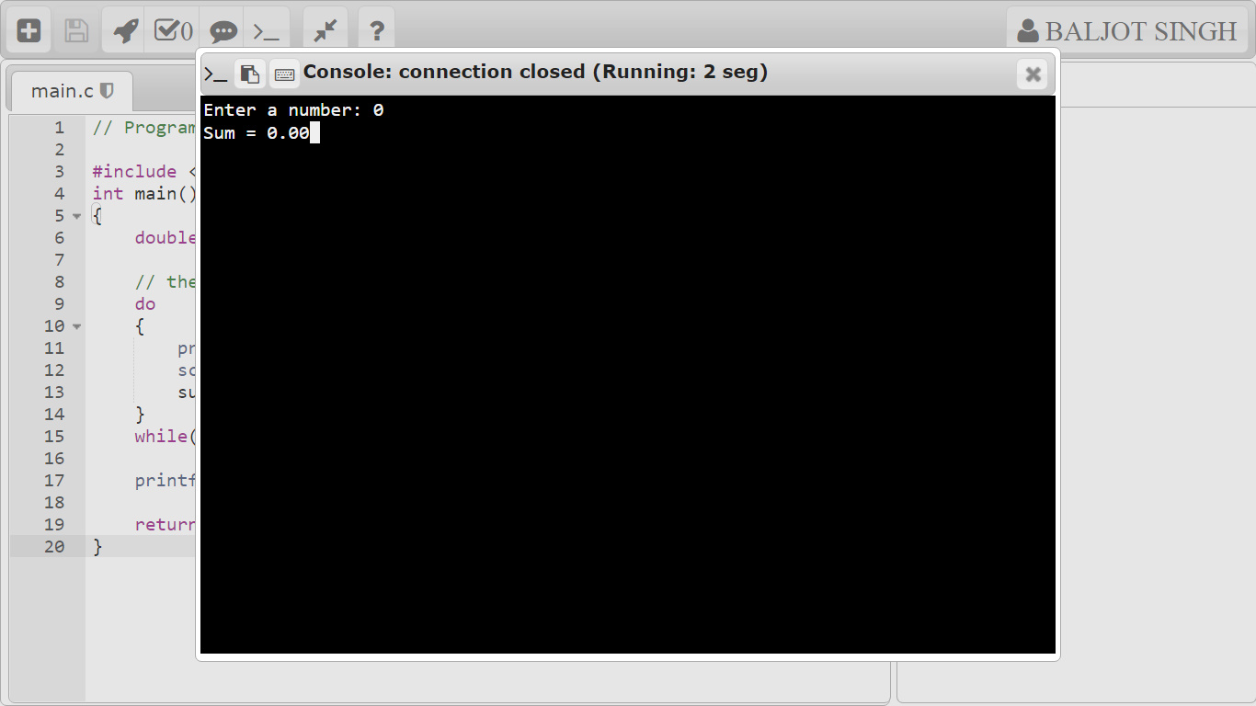

//program to use switch(break & continue)

#include <stdio.h>

int main()

{

int num=2;

switch(num+2)

{

case 1:

printf("Case1: Value is: %d", num);

case 2:

printf("Case1: Value is: %d", num);

case 3:

printf("Case1: Value is: %d", num);

default:

printf("Default: Value is: %d", num);

}

return 0;

}

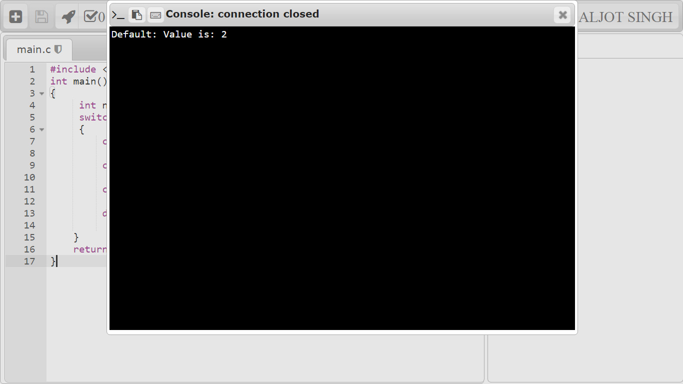

//program to implement and use function

#include<stdio.h>

// function prototype, also called function declaration

float square ( float x );

// main function, program starts from here

int main( )

{

float m, n ;

printf ( "\nEnter some number for finding square \n");

scanf ( "%f", &m ) ;

// function call

n = square ( m ) ;

printf ( "\nSquare of the given number %f is %f",m,n );

}

float square ( float x ) // function definition

{

float p ;

p = x * x ;

return ( p ) ;

}

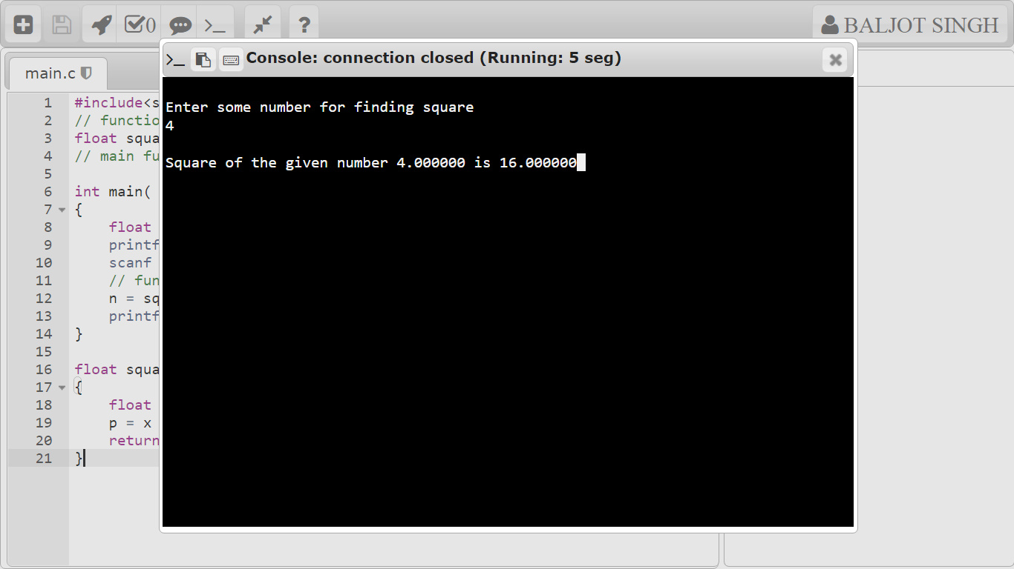

// Program to take 5 values from the user and store them in an array

// Print the elements stored in the array

#include <stdio.h>

int main() {

int values[5];

printf("Enter 5 integers: ");

// taking input and storing it in an array

for(int i = 0; i < 5; ++i) {

scanf("%d", &values[i]);

}

printf("Displaying integers: ");

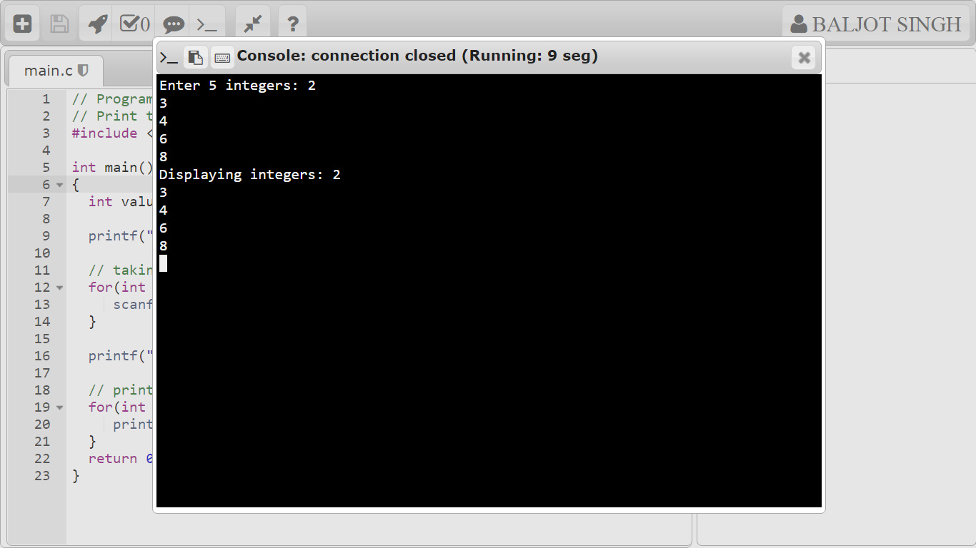

//program to use structures

#include <stdio.h>

struct student {

char firstName[50];

int roll;

float marks;

} s[10];

int main() {

int i;

printf("Enter information of students:\n");

// storing information

for (i = 0; i < 5; ++i) {

s[i].roll = i + 1;

printf("\nFor roll number%d,\n", s[i].roll);

printf("Enter first name: ");

scanf("%s", s[i].firstName);

printf("Enter marks: ");

scanf("%f", &s[i].marks);

}

printf("Displaying Information:\n\n");

// displaying information

for (i = 0; i < 5; ++i) {

printf("\nRoll number: %d\n", i + 1);

printf("First name: ");

puts(s[i].firstName);

printf("Marks: %.1f", s[i].marks);

printf("\n");

}

return 0;

}

